Height of a Right Circular Cylinder
# Source: AI Source: Provided by: [Data Path: Persons Table -> ID Column: 1, Name_En Column: Motasem Essam] -> From: [ChatGPT] on [7/25/2026]
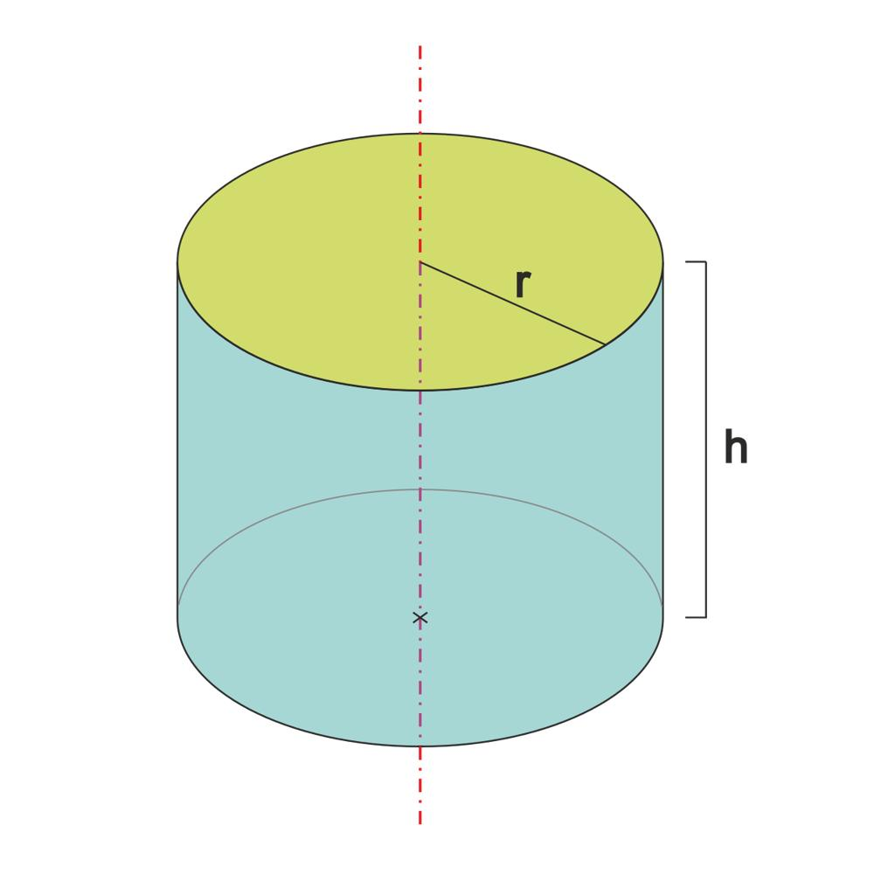
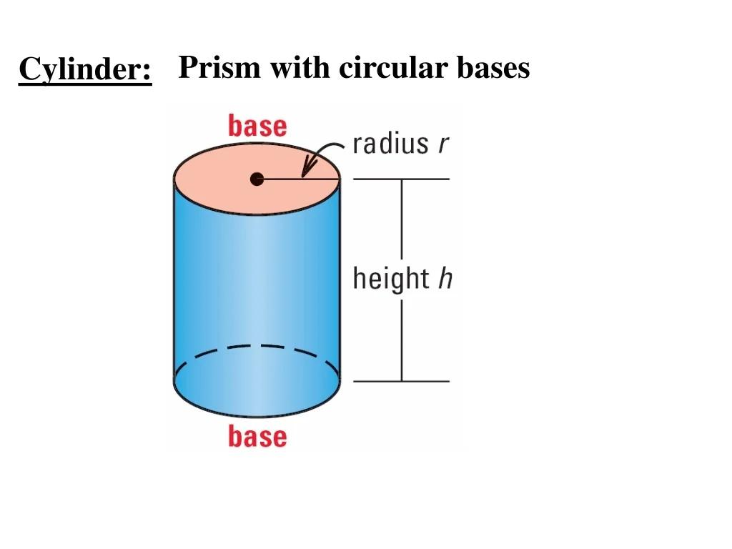
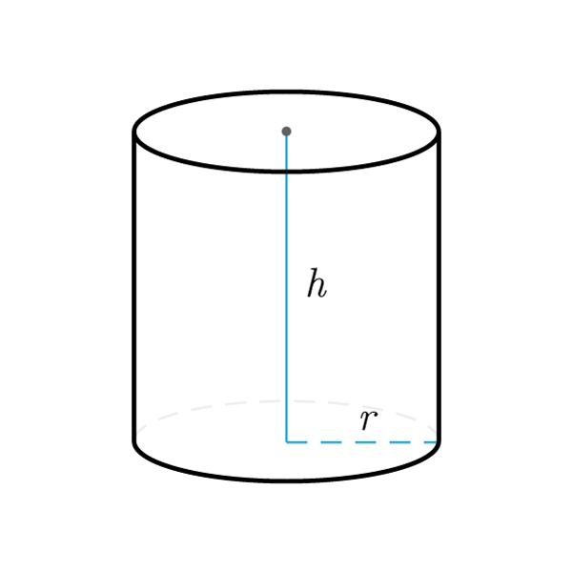

Definition
# Source: AI Source: Provided by: [Data Path: Persons Table -> ID Column: 1, Name_En Column: Motasem Essam] -> From: [ChatGPT] on [7/25/2026]
The height of a right circular cylinder is the perpendicular distance between its two parallel, congruent circular bases.
It is commonly represented by $h$ or $H$. In a right circular cylinder, the axis is perpendicular to both bases, and the height is equal to the length of the axis and the length of each straight lateral edge.
$$\boxed{h=\text{perpendicular distance between the bases}}$$

Simple Definition
# Source: AI Source: Provided by: [Data Path: Persons Table -> ID Column: 1, Name_En Column: Motasem Essam] -> From: [ChatGPT] on [7/25/2026]
The height of a right circular cylinder is the straight-up distance from its bottom circular base to its top circular base, measured perpendicular to the bases.

Geometric Representation
# Source: AI Source: Provided by: [Data Path: Persons Table -> ID Column: 1, Name_En Column: Motasem Essam] -> From: [ChatGPT] on [7/25/2026]

The height is associated with the following components:
- Top base: the upper circular face.
- Bottom base: the lower circular face.
- Height ($h$): the perpendicular distance between the two base planes.
- Axis: the line joining the centers of the two circular bases.
- Radius ($r$): the distance from the center of a base to its circumference.
- Lateral surface: the curved surface connecting the two circular bases.
Because this is a right circular cylinder, its axis is perpendicular to the base planes.

Mathematical Formulas

Height from Volume and Radius
# Source: AI Source: Provided by: [Data Path: Persons Table -> ID Column: 1, Name_En Column: Motasem Essam] -> From: [ChatGPT] on [7/25/2026]
The volume of a right circular cylinder is:
$$V=πr^{2}h$$
Rearranging:
$$\boxed{h=\frac{V}{πr^{2}}}$$

Height from Volume and Diameter
# Source: AI Source: Provided by: [Data Path: Persons Table -> ID Column: 1, Name_En Column: Motasem Essam] -> From: [ChatGPT] on [7/25/2026]
Since $r=D/2$:
$$V=\frac{πD^{2}h}{4}$$
Therefore:
$$\boxed{h=\frac{4V}{πD^{2}}}$$

Height from Curved Surface Area
# Source: AI Source: Provided by: [Data Path: Persons Table -> ID Column: 1, Name_En Column: Motasem Essam] -> From: [ChatGPT] on [7/25/2026]
For a right circular cylinder, the curved surface area is:
$$S_{L}=2πrh$$
Therefore:
$$\boxed{h=\frac{S_{L}}{2πr}}$$
Using diameter $D$:
$$\boxed{h=\frac{S_{L}}{πD}}$$

Height from Total Surface Area
# Source: AI Source: Provided by: [Data Path: Persons Table -> ID Column: 1, Name_En Column: Motasem Essam] -> From: [ChatGPT] on [7/25/2026]
For a closed right circular cylinder:
$$S_{T}=2πr^{2}+2πrh$$
Rearranging:
$$\boxed{h=\frac{S_{T}-2πr^{2}}{2πr}}$$
This formula assumes the cylinder includes both circular bases.

Height as Axis Length
# Source: AI Source: Provided by: [Data Path: Persons Table -> ID Column: 1, Name_En Column: Motasem Essam] -> From: [ChatGPT] on [7/25/2026]
For a right circular cylinder, the axis is perpendicular to the bases, so its length equals the height:
$$\boxed{h=L_{\text{axis}}}$$

Worked Examples
# Source: AI Source: Provided by: [Data Path: Persons Table -> ID Column: 1, Name_En Column: Motasem Essam] -> From: [ChatGPT] on [7/25/2026]
Example 1: Finding height from volume
Given:
- Volume: $V=200π{\text{ cm}}^{3}$
- Radius: $r=5\text{ cm}$
Solution:
$$h=\frac{V}{πr^{2}}=\frac{200π}{π{\left(5\right)}^{2}}$$
$$h=\frac{200}{25}$$
Answer: $\boxed{h=8\text{ cm}}$
Example 2: Finding height from curved surface area
Given:
- Curved surface area: $S_{L}=60π{\text{ cm}}^{2}$
- Radius: $r=3\text{ cm}$
Solution:
$$h=\frac{S_{L}}{2πr}=\frac{60π}{2π\left(3\right)}$$
Answer: $\boxed{h=10\text{ cm}}$
Example 3: Finding height from diameter and volume
Given:
- Diameter: $D=4\text{ m}$
- Volume: $V=48π{\text{ m}}^{3}$
Solution:
$$h=\frac{4V}{πD^{2}}=\frac{4\left(48π\right)}{π{\left(4\right)}^{2}}$$
$$h=\frac{192}{16}$$
Answer: $\boxed{h=12\text{ m}}$

Key Characteristics
# Source: AI Source: Provided by: [Data Path: Persons Table -> ID Column: 1, Name_En Column: Motasem Essam] -> From: [ChatGPT] on [7/25/2026]
- Height is a linear measurement, not an area or volume.
- It is measured perpendicular to the base planes.
- The two circular bases are parallel and congruent.
- The axis length equals the height in a right circular cylinder.
- The height affects volume and lateral surface area linearly when the radius is fixed.
- Height is distinct from the slant length or axis length of an oblique cylinder.

Comparison with Related Measurements
# Source: AI Source: Provided by: [Data Path: Persons Table -> ID Column: 1, Name_En Column: Motasem Essam] -> From: [ChatGPT] on [7/25/2026]
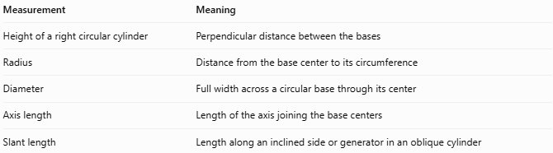
Measurement | Meaning
Height of a right circular cylinder | Perpendicular distance between the bases
Radius | Distance from the base center to its circumference
Diameter | Full width across a circular base through its center
Axis length | Length of the axis joining the base centers
Slant length | Length along an inclined side or generator in an oblique cylinder
Important distinction: In a right circular cylinder, height equals the axis length. In an oblique circular cylinder, the axis or slant length is generally greater than the perpendicular height.

Applications
# Source: AI Source: Provided by: [Data Path: Persons Table -> ID Column: 1, Name_En Column: Motasem Essam] -> From: [ChatGPT] on [7/25/2026]
- Geometry: calculating volume and surface area.
- Engineering: specifying the axial dimension of cylindrical components.
- Construction: measuring cylindrical columns and tanks.
- Manufacturing: defining the length of cylindrical rods and sleeves.
- Storage design: determining the capacity of cylindrical containers.

Key Points
# Source: AI Source: Provided by: [Data Path: Persons Table -> ID Column: 1, Name_En Column: Motasem Essam] -> From: [ChatGPT] on [7/25/2026]
- Symbol: $h$ or $H$
- Definition: perpendicular distance between the two circular bases.
- From volume: $h=V/\left(πr^{2}\right)$
- From curved surface area: $h=S_{L}/\left(2πr\right)$
- For a right cylinder: height equals axis length.

Conclusion
# Source: AI Source: Provided by: [Data Path: Persons Table -> ID Column: 1, Name_En Column: Motasem Essam] -> From: [ChatGPT] on [7/25/2026]
The height of a right circular cylinder is the perpendicular distance between its parallel circular bases. Because the axis is perpendicular to the bases, the height also equals the axis length. It is essential for calculating the cylinder's volume and surface area.

